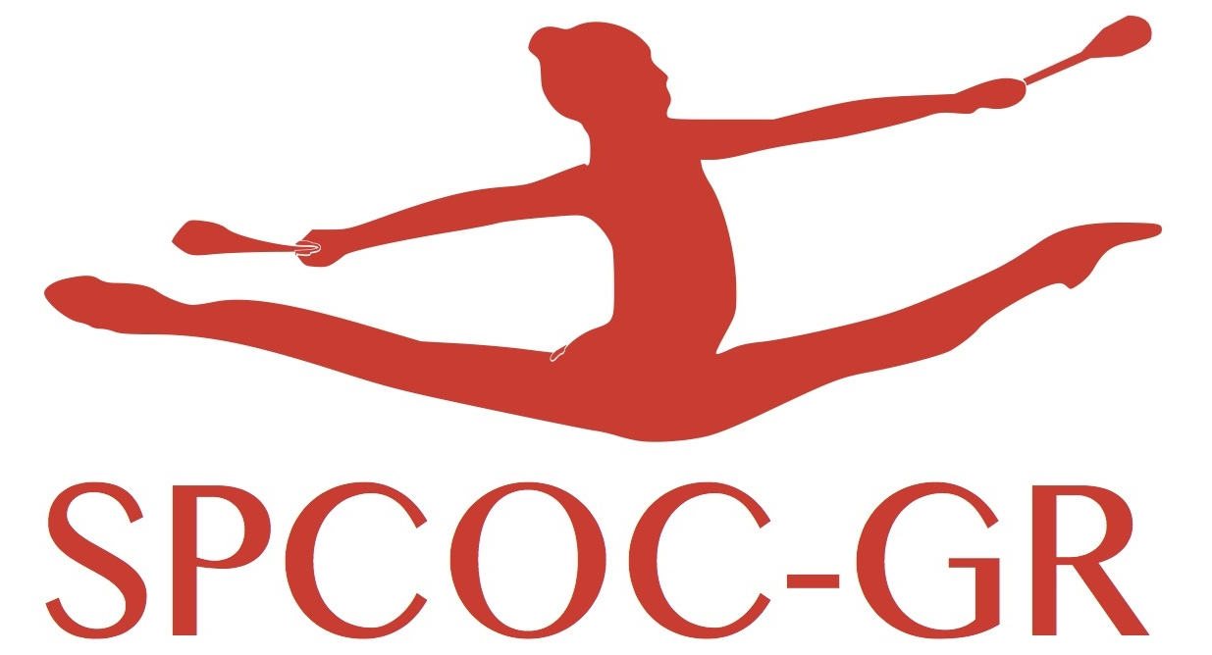

[Image Rights](https://www.inbrief.co.uk/human-rights/image-rights/)

The club representative . . . . . . . . . . . . . . . . . . . . . . . . . . . . . certifies that the legal representatives (fathers, mothers or legal guardians) of the gymnasts taking part in the International Azur Tournament, authorizes SPCOC-GR to take pictures and video of the gymnasts taking part to the competition and gives rights to the use of these images to be published on Internet or in the press magazins.

Indicate in this table the gymnasts that are refusing these publications:

|  |  |  |  |
| --- | --- | --- | --- |
| Full name | Category | Name of legal representative | signature |
|  |  |  |  |
|  |  |  |  |
|  |  |  |  |
|  |  |  |  |
|  |  |  |  |
|  |  |  |  |
|  |  |  |  |
|  |  |  |  |
|  |  |  |  |
|  |  |  |  |
|  |  |  |  |

Date : representative responsible for the club.