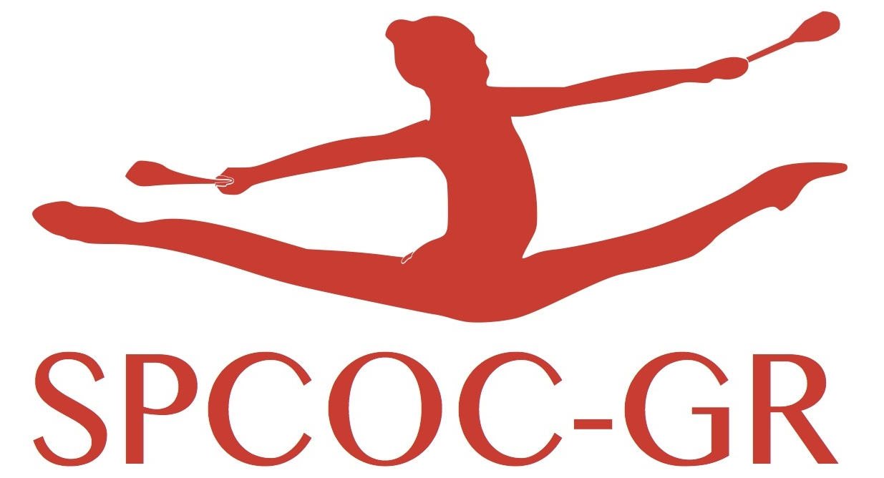
Image Rights

The club representative . . . . . . . . . . . . . . . . . . . . . . . . . . . . . certifies that the legal representatives (fathers, mothers or legal guardians) of the gymnasts taking part in the International Azur Tournament, authorizes SPCOC-GR to take pictures and video of the gymnasts taking part to the competition and gives rights to the use non-commercial law of these images to be published on Internet or in the press magazins.

Indicate in this table the gymnasts that are refusing these publications:
Full name | Category | Name of legal representative | signature

Date : representative responsible for the club.

