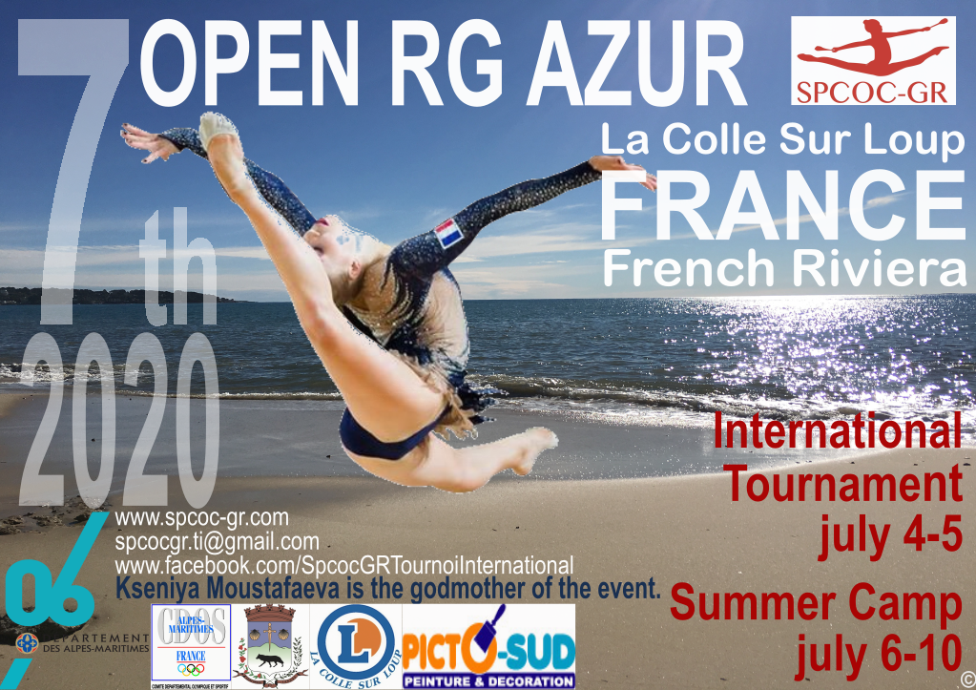

**OPEN RG AZUR: July 4 and 5, 2020**

**Summer Camp: from July 6 to 10, 2020**

Dear Friends,

The SPCOC GR is delighted to invite you to the 7th edition of its international rhythmic gymnastics’ tournament in La-Colle-sur-Loup, OPEN RG AZUR.



**COMPETITION PLACE**

**Gymnase Emilie Fer**

4 Boulevard Alex ROUBERT

06480 La Colle-Sur-Loup

FRANCE

**CONTACT**



Mail : spcocgr.ti@gmail.com



Facebook : [SpcocGrTournoiInternational](http://www.facebook.com/SpcocGrTournoiInternational)



Instagram : spcocgr

**INFORMATION**

From 9 :00 a.m. to 7 :00 p.m. time zone Paris GMT+2

Via WhatsApp

|  |  |  |
| --- | --- | --- |
| **Administrative via WhatsApp** | **Phone Numbers** | **Spoken Languages** |
| Frédéric Ferra | + 33 6 63 34 06 28 | French/English |
| Margaux Mougel | +33 6 32 82 38 93 | French/English/Simplified Chinese writing |
| Annaëlle Ferra | + 33 6 63 99 77 96 | French/Spanish |
| Johanna Rodrigues de Castro | +33 6 63 00 42 44 | French/Portuguese |
| Nathalia Boufaied | +33 6 59 76 26 44 | French/Russian |

|  |  |  |
| --- | --- | --- |
| **Technique via WhatsApp** | **Phone Numbers** | **Spoken Languages** |
| Reneta Nesheva | + 33 6 58 03 47 40 | Bulgarian/Russian |
| Clarisse Daudin | + 33 6 68 32 60 42 | French/English |
| Annaëlle Ferra | + 33 6 63 99 77 96 | French/Spanish |

**RULES (FIG Code 2017-2020)**

|  |  |  |
| --- | --- | --- |
| INDIVIDUAL COMPETITION «**A**» Choice your apparatus / Age classification / depending on the number of entries | | |
| **S** Min 1(2004et +) ,Min 2(others);R Min 1;**AD** Min 1(2004et +) no mini/maxi (others); BD:Min 3  Diff Code FIG junior ; Diff Code FIG senior | | |
| **Category** | **Apparatus** | **Without Apparatus (WA)** |
| 2004 et - (2 apparatus) | 9 BD (Max) / 10 points |  |
| 2006/2005 (2 apparatus) | 8 BD (Max) / 9 points |  |
| 2008/2007 (2 apparatus) | 7 BD (Max) / 8 points |  |
| 2010/2009 (1 apparatus + WA) | 6 BD Max / 7 points | 7 BD Max / 8 points |
| 2011/2012/2013 et +  (WA + 1 apparatus) | 6 BD Max / 6 points | 7 BD Max / 6 points |

|  |  |  |
| --- | --- | --- |
| INDIVIDUAL COMPETITION «**B**» choice your apparatus / Age classification / depending on the number of entries | | |
| **S** Min 1(2004 and +) ,Min 2(others);R Min 1;**AD** Min 1(2004 et +) no mini/maxi (autres); BD:Min 3 ;  Diff Code FIG junior ; Diff Code FIG senior | | |
| **Category** | **Apparatus** | **Without Apparatus (WA)** |
| 2004 et - (2 apparatus) | 8 BD Max / 6.5 points |  |
| 2006/2005 (2 apparatus) | 7 BD Max / 6 points |  |
| 2008/2007 (2 apparatus) | 7 BD Max / 5.5 points |  |
| 2010/2009 (1 apparatus + WA) | 6 BD Max / 5 points | 7 BD Max / 6 points |
| 2013/2012/2011 (1 apparatus + WA) | 6 BD Max / 4 points | 6 BD Max / 5 points |
| 2014 et + ( WA) |  | 6 BD Max / 4 points |

|  |  |  |
| --- | --- | --- |
| INDIVIDUAL COMPETITION «**C**» choice your apparatus / Age classification / depending on the number of entries | | |
| S : Min 2 ; R : Min 1 ; **AD** :Min 1(2003 et +) ; **BD** : Min 3 ; Diff valeur max 0,2 pt | | |
| **Category** | **Apparatus** | **Without Apparatus (WA)** |
| 2004 et - (1 apparatus) | 7 BD Max / 5 points |  |
| 2006/2005 (1 apparatus) | 6 BD Max / 4.5 points |  |
| 2008/2007 (1 apparatus) | 6 BD Max / 4.5 points |  |
| 2010/2009 (1 apparatus ) | 6 BD Max / 4 points |  |
| 2011/2012/2013 et + (WA) |  | 5 BD Max / 2.5 points |

**PARTICIPATION FEES**

* 30 € per gymnast
  + Cost reduction of 10 € if registration to the 3rd GR Very Nice 2020
* Registration Form:

<https://forms.gle/ihD1xJ1yi5J722hv8>

* Or Registration excel file :

<http://www.spcoc-gr.com/wp-content/uploads/2020/02/TIA-simplified-registration-form.xlsx>

* **Registration deadline: May 30, 2020**
* invitation for the visa request (for countries outside Europe):

<http://www.spcoc-gr.com/wp-content/uploads/2020/01/visa-request.docx>

* Rules:

<http://www.spcoc-gr.com/wp-content/uploads/2020/01/conditions-de-participation-au-TIA-EN.docx>

**REGISTRATION PAYMENT METHODS**

* **By Wire/Transfer Payment (before May 15)** 
  + **IBAN : FR76 3000 3009 4300 0372 7110 991**
  + **BIC : SOGEFRPP**

**It is mandatory to send an associated email with the reference number of the wire transfer and Club Name to** [**spcocgr.ti@gmail.com**](mailto:spcocgr.ti@gmail.com)

**PUBLIC ENTRY FEES**

* 1 Day 6€
* Week-end 10€
* Free for people under 18 years old

**MUSIC only MP3 format**

* Send your music in MP3 format only to [spcocgr.ti@gmail.com](mailto:spcocgr.ti@gmail.com) before June 15, the files should be named in this format: LastName_FirstName_Apparatus_Category (use wetransfer.com to send your music.mp3)

The received files will remain **confidential.**

We recommend that you come with a backup stored on a USB key (no way to read CD nor DVD)

**JUDGES**

* Each delegation must present at least 1 judge for 5 gymnasts’ range. Failure to present a judge: **a penalty fee of 100 €**
* Lunches are offered to the judges during the competition

**IMAGE RIGHT**

* Form to print and fill:

<http://www.spcoc-gr.com/wp-content/uploads/2020/01/Droit-ImageEN.docx>

**INSSURANCE**

Gymnasts must have their apparatus, be licensed in their club / country of origin, be up to date with their insurance.

The organizer cannot be held responsible in the event of an accident, illness, repatriation, etc. All participants are responsible for taking their own arrangements in order to have the necessary valid insurance cover against illness, accidents and the repatriation of all members of their delegation.

**COMPETITION PROGRAMME**

* Friday
  + Gymnasts arrival and installation (from 12:00 a.m.)
  + « Welcome drink » at 7:00 p.m.
* Saturday
  + Judge’s meeting at 8:00 a.m.
  + Beginning of the competition and exhibitions
  + Awards ceremony
  + Festive evening with coaches and judges
* Sunday
  + 2nd day of the competition and exhibitions
  + Awards ceremony
  + Drink closing ceremony

The time plan of the competition will be specified according to the number of participating gymnasts. The detailed schedule will be sent to all participating clubs.

**AWARDS**

* The 1st gymnast in each category has the SUMMER CAMP week offered (saving € 175)
* All gymnasts will receive a participation gift

**MISS CONTEST**

* All the participants in the tournament participate in the Miss Contest

**RESTAURATION**

* Refreshments and Snack on site

**TRANSPORTATION SERVICES**

* **Taxi Olivier**. A welcome and help in organizing your stay in our region. All distances, visit of the region, airport transfer, train station 7/7 and 24/24

Tel : +33 6 11 53 50 89 taxilacolle@gmail.com WhatsApp

* **Gilbert DA COSTA. Tpmr Glc Prestige.** Specialist in the transport of people with reduced mobility, our company carries out all your journeys for airports, stations… all distances.

Tel : [+33](tel:06%2068%2060%2003%2061) 7 61 66 65 90 [gilbertdacosta61@gmail.com](mailto:gilbertdacosta61@gmail.com) WhatsApp

* **Taxi Richard.** All distances, 24/24

Tel : +33 6 03 49 80 61 [montrodat1960@gmail.com](mailto:montrodat1960@gmail.com)



**Summer training camp RG AZUR 2020**



**Training from Monday 6 to Friday July 10** atGymnase Emilie Fer in La Colle-Sur-Loup

Gymnasts must have their apparatus, be up to date with their insurance and belong to a RG federation.

**FEES**

* Training camp 175 € (35€ per day)

**PLANNING**

* Physical training
* Stretching and Flexibility
* Difficulties work
* Apparatus work
* 45 minutes of Dance per day

On Tuesday and Thursday morning, outdoor physical preparation (at the stadium)

Training from 9:00 a.m. to 4:00 p.m. with a 1.5-hour break

(30 minutes for lunch, 1-hour of swimming pool)

**CONTACT**

Email: [spcocgr.ti@gmail.com](http:///h)

** The club can provide a personal invitation for the visa request (for countries outside Europe):

<http://www.spcoc-gr.com/wp-content/uploads/2020/01/visa-request.docx>

**PAYMENT**

* **By Wire/Transfer Payment (before June 1st)** 
  + **IBAN : FR76 3000 3009 4300 0372 7110 991**
  + **BIC : SOGEFRPP**

**It is mandatory to send an associated email with the reference number of the wire transfer and Club Name to** [**spcocgr.ti@gmail.com**](mailto:spcocgr.ti@gmail.com)

**REGISTRATION**

Formulaire en ligne : <https://forms.gle/5aA5PKpif1qHePb99>

Ou document excel : http://www.spcoc-gr.com/wp-content/uploads/2020/02/SIA-simplified-registration-form.xlsx

**RULES**

<http://www.spcoc-gr.com/?p=2216>

**TECHNICAL SUPERVISORS**

• **Reneta Nesheva** (Bulgaria) Student of legendary trainer Neshka Robeva.

Multiple champion of Bulgaria, winner at the World and European Championships but also at the Olympic Games.

National coach of Bulgaria, she coached winners of the 2008-2010 European championships (Boyanka Angelova and others) and trained several champions of Bulgaria.

• **Annaelle Ferra** (France) – Student of Reneta Nesheva, coach for SPCOC-GR.

**INSSURANCE**

The gymnasts must have their apparatus, be licensed in their club / country of origin, be up to date with their insurance.

The organizer cannot be held responsible in the event of an accident, illness, repatriation, etc. All participants are responsible for taking their own arrangements in order to have the necessary valid insurance cover against illness, accidents and the repatriation of all members of their delegation.

**ACCOMMODATIONS**

<https://www.spcoc-gr.com/competitions-et-tournois-internationaux/accommodations>



**PARTNERSHIPS**

[www.departement06.fr](http://www.departement06.fr)



[www.cdos-06.fr](http://www.cdos-06.fr)



<https://www.lacollesurloup.fr>



[www.acc-experts.com](http://www.acc-experts.com)



[www.e-leclerc.com/auredis](http://www.e-leclerc.com/auredis)

D:\PERSO\GR\logo\PICTOSUD.jpg

[www.nosartisansontdutalent.fr/entreprise/pictosud-1/](http://www.nosartisansontdutalent.fr/entreprise/pictosud-1/)